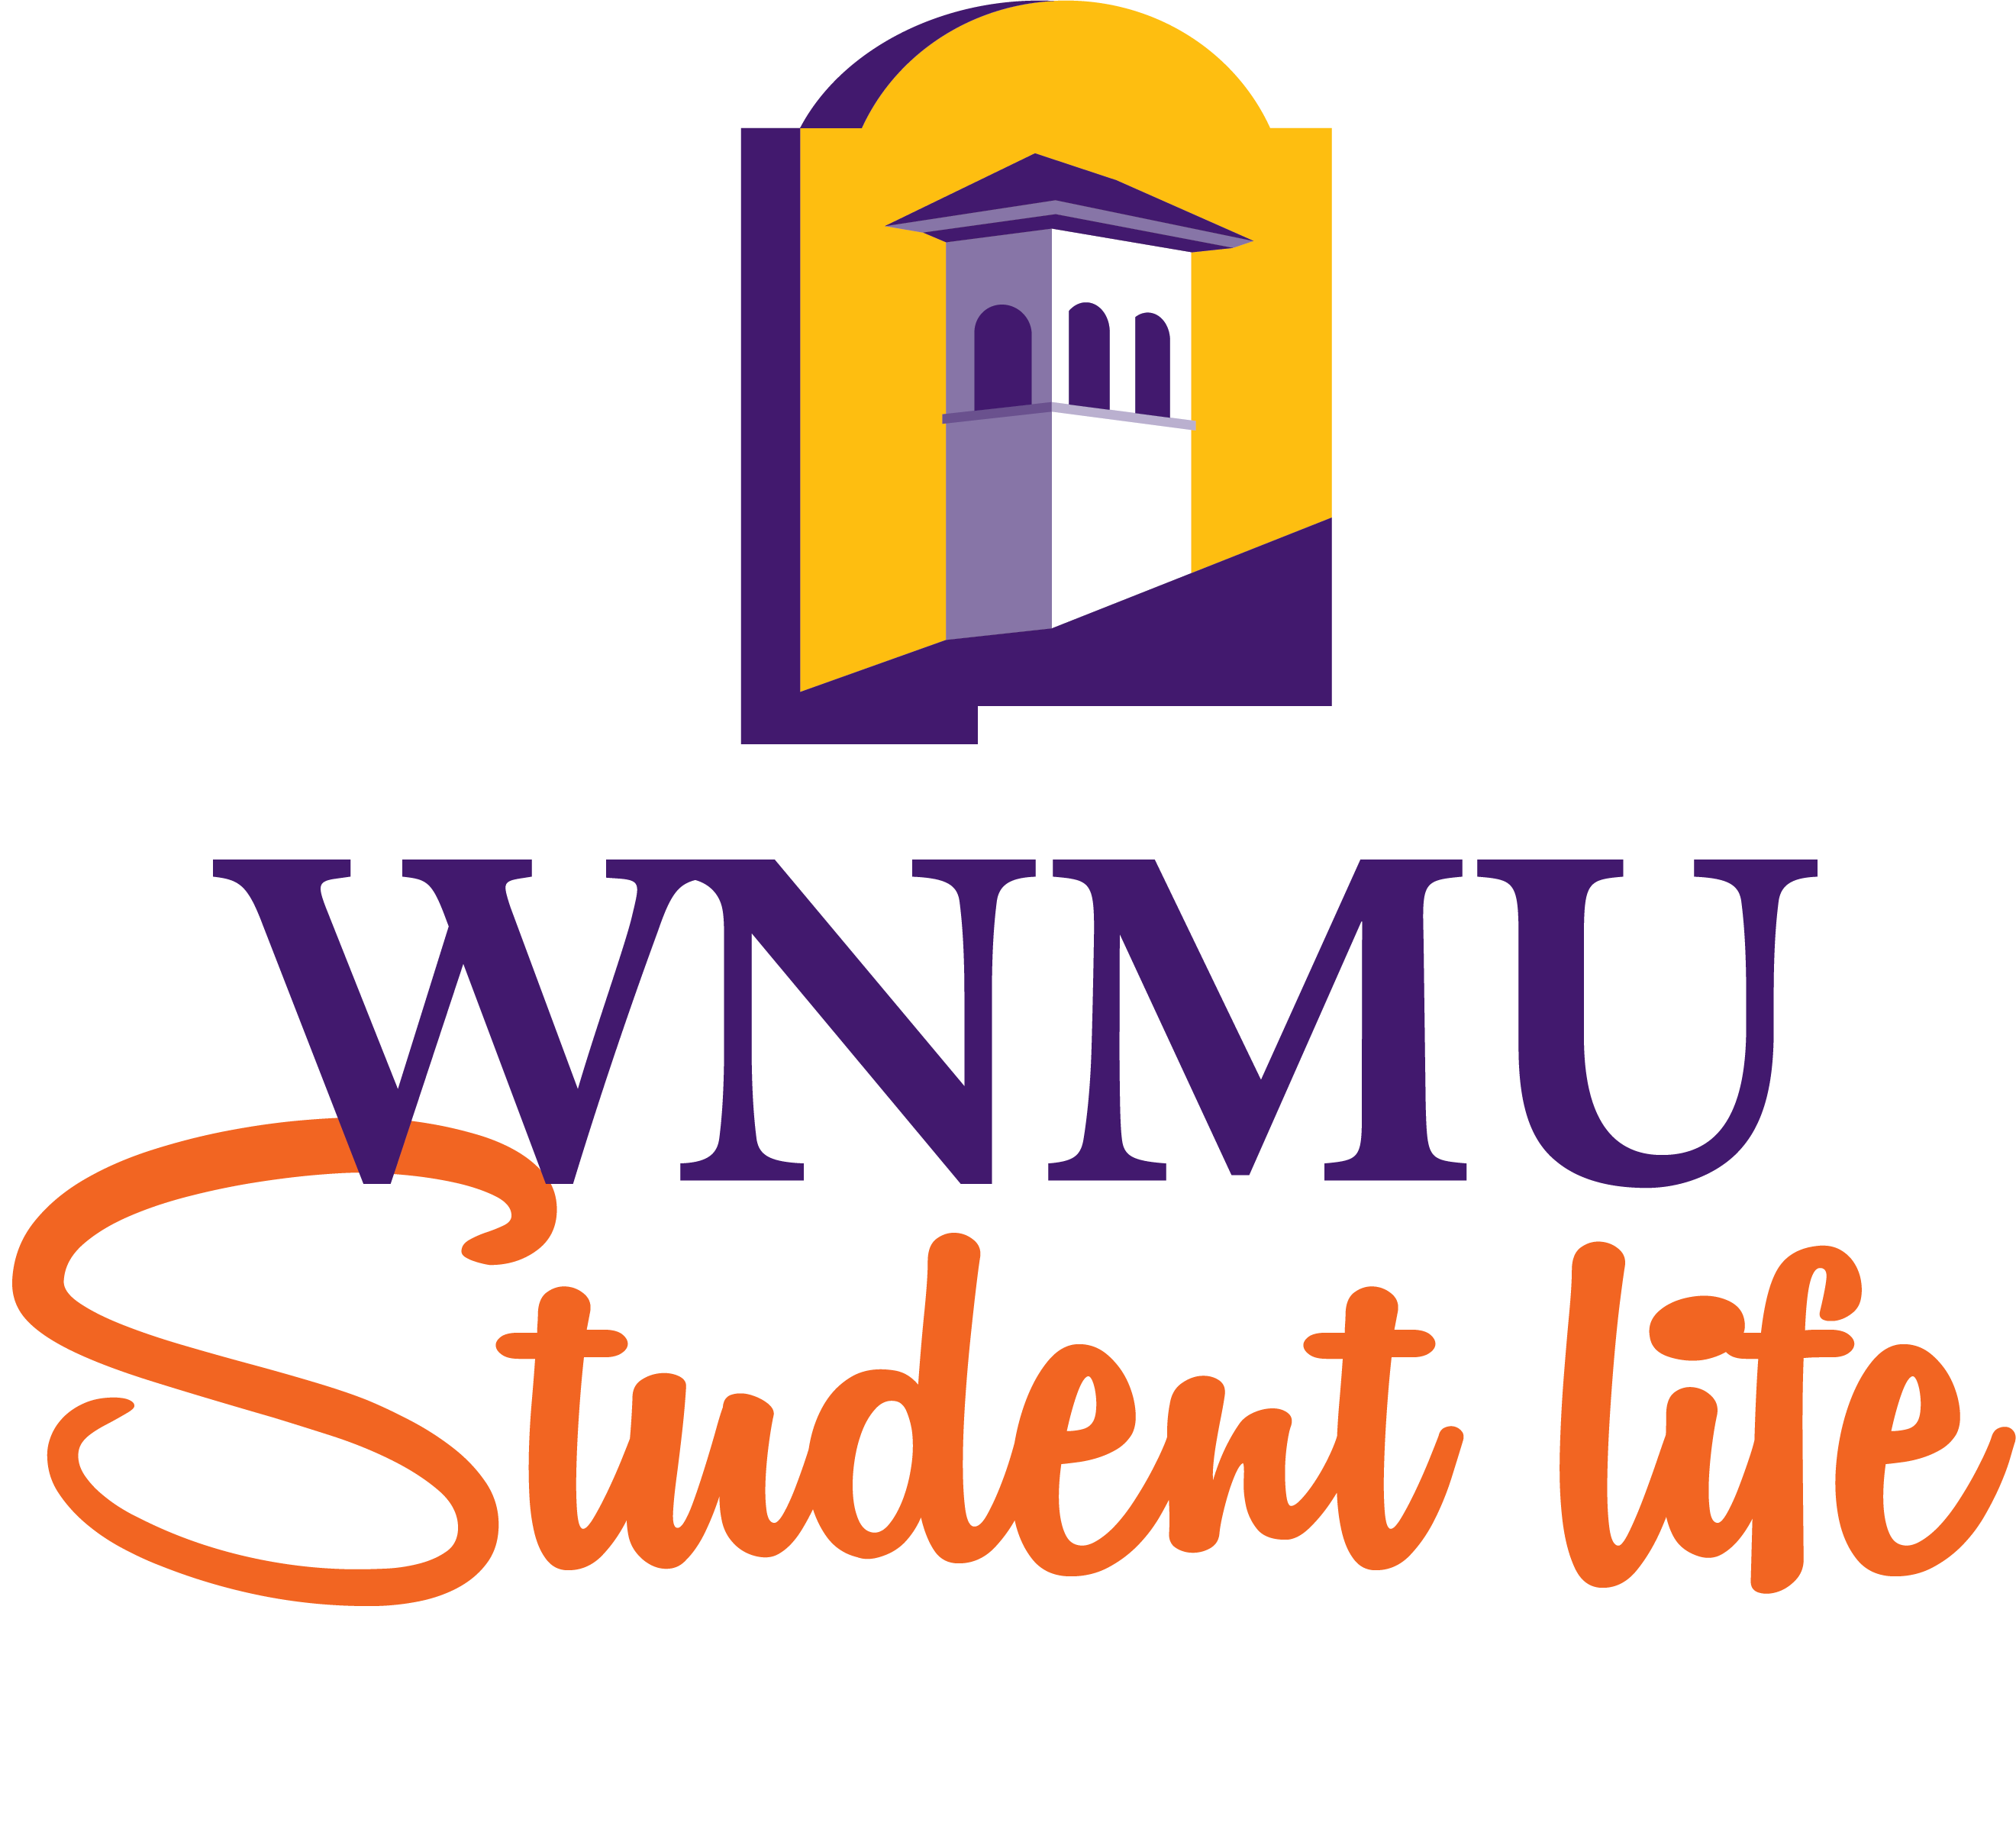

REGISTERED STUDENT ORGANIZATIONS MANUAL
Student clubs/organizations found on campus enrich the social, cultural, and educational experiences of Western students, influence the larger University community, and enhance the overall diversity found at WNMU. Student clubs and organizations will be overseen by the Department of Student Life.
All of the criteria listed below must be met in order for a club/organization to be recognized as an official WNMU club/organization.
How to Start a New Club or Organization
Forming a Student Organization is easy. Completing the following steps will ensure that the process of forming an organization is accomplishable in approximately one week. This handbook is designed to explain those steps in detail so that after having read it, you have all the information necessary for forming an organization. The steps are:
- Conduct an Organization Meeting
- Select an Advisor
- Create a Constitution
- Elect Student Officers
- Complete Authorized Signature Form
If these steps are followed as specified below, you will have no problems in getting your organization started.
The Organizational Meeting
When an individual student or group of students is interested in forming an organization, they should advertise to the University that there will be a meeting for anyone interested in belonging to the specific organization. A temporary student secretary should be selected to take minutes at this meeting. At the meeting it is important to explore the interests of the group so that you can formulate the purpose of the organization. Once you have agreed to a statement that best describes the functioning purpose of the organization, you put it in writing on the signature authorization form. This same section is also noted in the constitution.

The Constitution
There is no specific format for the Constitution. Each organization’s constitution is as different and unique as the many organizations themselves. The following is a list of sections or articles that are usually contained in a constitution:
- Name of Student Organization
- Purpose of Student Organization
- Student Officers and Responsibilities
- Student Elections
- Vacancy of Office
- Removal from Office
- Meetings
- Funding
- Amendments
- Jurisdiction
- Dissolution
- Creation Date
- Latest Revision Date
- When the constitution is completed, the members must vote to ratify the Constitution and this has to be done by a 2/3 vote. A record of this ratification should be kept in a set of minutes that a temporary secretary kept for the organizational meeting(s).
Election of Officers
Student Officers for your organization have to be elected according to the guidelines set forth in your constitution. You are not required to have the traditional President, Vice-President, Secretary and Treasurer, but your officers should be able to facilitate the same functions. Officers should be dependable and responsible students that are willing to put in a little extra time so that the organization will run smoothly. Officers are the backbone of an organization so be careful to select the people that will best meet your needs. To hold an office, a student must be in good standing with a minimum 2.0 or better cumulative grade point average.
Selection of Advisor
An advisor is determined to be an employee of the University and not a student. When selecting an advisor, you should consider persons who have training in the areas of the club’s focus. If it is a Jogging Club, then perhaps it would be best to select someone form the Physical Education Department who specializes in jogging. It’s always best to do so, but in cases where this is impossible, you should try to select someone who will best meet the organization’s needs. This person is responsible to attend all meetings and activities sponsored by the organization and should be readily available for advice, and to sign appropriate forms.
Once the Advisor has been selected, you should then fill out the Authorized Signature Form.
Authorized Signature Form
The Authorized Signature Form was designed to allow the Department of Student Life and the Business Office to know exactly which club members of the organization are allowed to sign papers for the organization. The majority of signatures will be needed when the organization is going to spend some of their funds, therefore, it is mandatory that documents are countersigned by the advisor so that other individuals can be aware of what is going on with the organization’s funds. In the event of a vacancy, new Signature Authorization forms should be completed.
The Final Steps
Once all the forms have been completed and approved, the Officers of the group are required to meet with the club advisor to discuss them. The advisor will review them to insure that they contain nothing that violates any University policies, State or Federal Laws. If the forms are not approved, the group will be asked to review the items in question and resubmit them when corrected. If no violations are found, the documents will be approved and placed on file with the Student Life office.
Club Recruitment and Retention
Each student club/organization will be required to take certain steps to maintain campus involvement and club expansion.
Each club/organization will be required to participate in Welcome Week (August and January), Homecoming (September), Great Race (April), and New Student Orientation (May-August) each year.
Clubs are required to host a minimum of two club events per academic semester (Fall and Spring). You must email the event date, time, location, and attendance to April Burt (aburt@wnmu.edu) after the event to maintain records.
A clubs/organizations banquet will be held at the end of each academic year. An award packet will be given out prior to the banquet for each club to fill out in order to be considered for awards. Throughout the year, it would be smart to keep the award categories in mind in order to craft your programming around those and help in filling out your packet at the end of the school year. These categories are:
- Individual Awards
  - Rising Star Member
  - Outstanding Student Leader
- Program Awards
  - Best New Program
  - Best Program
- Group Awards
  - Rising Star Organization
  - Student Organization of the Year
Funding
Funding is available to all student organizations through an easy application process. Each club and organization is encouraged to apply for funding grants, of any dollar amount, that can be used for the following reasons:
- Facilitating a campus event
- Facilitating a community event
- Attending a conference related to your organization’s mission
- Promoting WNMU through community service or outreach
Grant application forms are available in the Department of Student Life and online at https://life.wnmu.edu/rso/grant-funding-application/. In order to qualify for grants, the club must be in good standing with the Department of Student Life by participating in required events and hosting required club events during the year, as specified above.
Disbandment of a club/organization
Clubs/organizations that are inactive for two academic years will be disbanded. Inactive status will be determined if the following criteria has not been met:
- Minimum required amount of club hosted events.
- Minimum required participation in Student Life events.
Any remaining funds in a club/organization account will be liquidated and added to the general fund account for club startup and renewal funding.
We look forward to supporting your organization as you work to enhance the WNMU student experience. For more information, contact aburt@wnmu.edu.

__________________________________________________ ________________
Club executive member Date
Application to establish a Registered Student Organization
Name of RSO:

Title | Name | Phone | email
President
Vice-President
Secretary
Treasurer
Other
Sponsor/Advisor

*******For office use only*******

Received by: _____________________________ Date: ______________ Time: _________
Constitution approved Yes/No: _________
Authorized signature form received Yes/No: _________
Agency account balance at time of application $ ___________. Attached print out Yes/No: ____

